Homework 2

Problem 1:

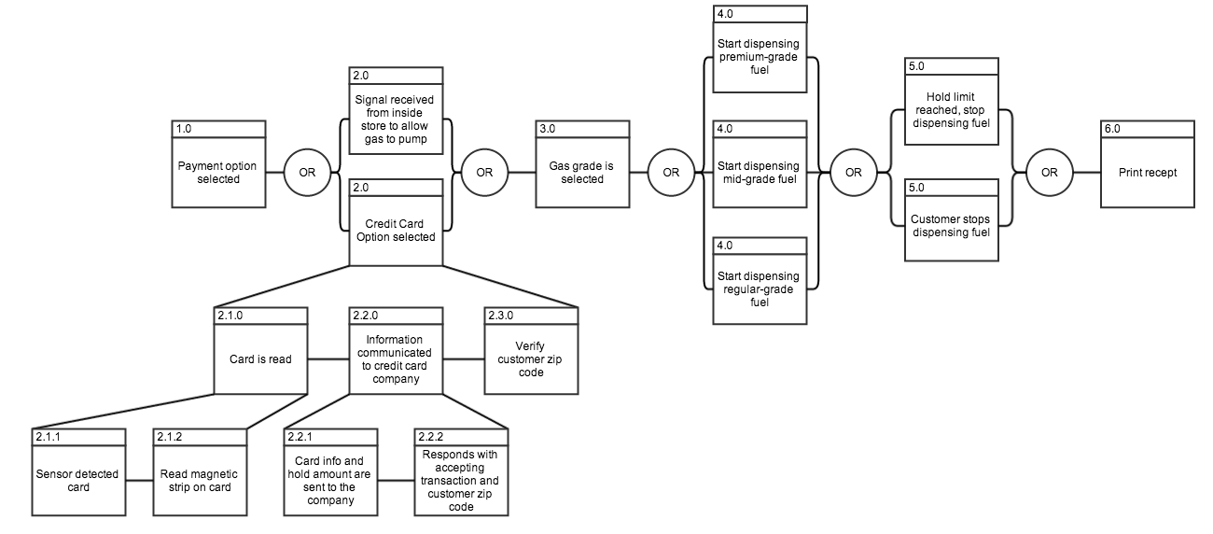

Problem 2:

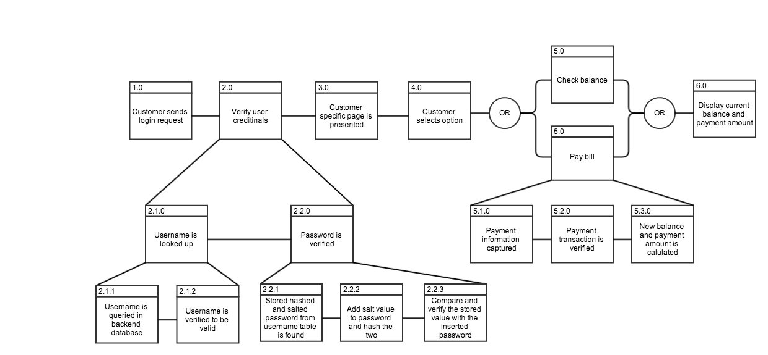

Problem 3:

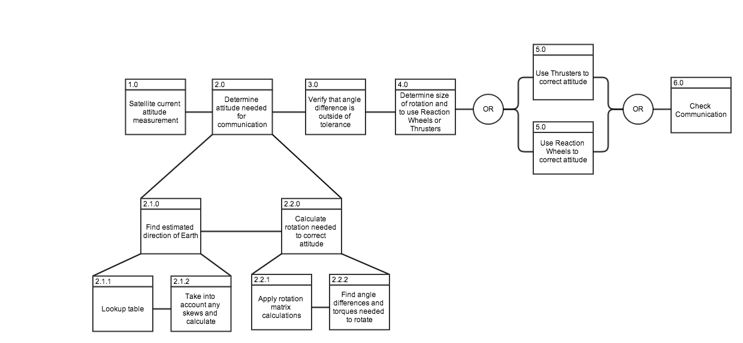

I also attached the photos separately, so you may see them at a higher resolution.